Artificial and Computational Intelligence Assignment 2
Problem Statement 15: Group 153

List of all the team member’s BITS ID and Name for this assignment:
Sr. No | BITS ID | Name | % Contribution
1 | 2024AA05731 | Suraj Anand | 20
2 | 2024AA05732 | Ashvini Satish Bhosale | 20
3 | 2024AA05733 | Bollam Manindra | 20
4 | 2024AA05734 | S. Hari Chandana | 20
5 | 2024AA05735 | Nikhil Yadav | 20

Problem statement 1 : Gaming - Two-player Solution-Based Crossword Puzzle

- Objective:
- Use Min-Max algorithm and implement the game in PYTHON
- Interactive implementation. Dynamic inputs-based run of the game with step wise board display and error free game ending

- Assumptions:
- The game is a two-player turn-based crossword puzzle.
- Initial stage of the crossword puzzle is taken as any one word already put on the board.
- One player will have one chance to place the given word and then second player gets a chance to play. So one player one chance is followed.

The first word, "RABBIT," in the grid, and subsequent words must cross at least one existing word/letter. The game uses the Minimax algorithm to determine optimal moves in automated mode.

1. The grid is 12x9, initialized with `#` symbols.
2. The first word, "RABBIT," is always placed in the grid.
3. Words must cross at least one letter of an existing word.
4. Invalid placements result in score deductions.
5. Players take turns, with scores displayed after each move.
6. In AI mode, Minimax evaluates placements to maximize the score while minimizing invalid placements.
7. The game ends when all words are placed or no valid moves remain.

How It Works:
Interactive: Two-Player Mode:
- Players take turns selecting a word and placing it on the grid.
- The word must cross an existing word, or the player loses points.
- Scores update after each move based on word length and validity.
- The game continues until all words are placed or no valid moves remain.

Automated: Best solution(AI Mode):
- The Minimax algorithm simulates multiple placements and selects the best moves.
- The AI ensures words cross existing ones and optimizes scoring.
- The process runs iteratively to find the two highest-scoring solutions.
- The best solutions are displayed at the end with the final grid layout.

- Our Understanding of the Problem:
- Players earn points based on the number of letters in a correctly placed word on the puzzle grid.
- If a word is placed incorrectly, 1 point is deducted, and the turn passes to the next player.
- The process repeats until all words are placed correctly in the grid.
- The game runs for 10 iterations, trying different placements of words.
- The two best solutions (highest points) are selected after 10 iterations.
- A random seed is not to be used, meaning results may vary in different runs.
- The final output should contain variable-value details (likely placements of words and scores).
- This is a collaborative yet competitive crossword-solving game where players try different word placements until the correct solution is found.
- The word length determines the points awarded to the player.
- At the end, the two best solutions (potentially those with the highest scores) are chosen.

- Problem Output Screenshot:

  - Input is 2 (AI Mode)
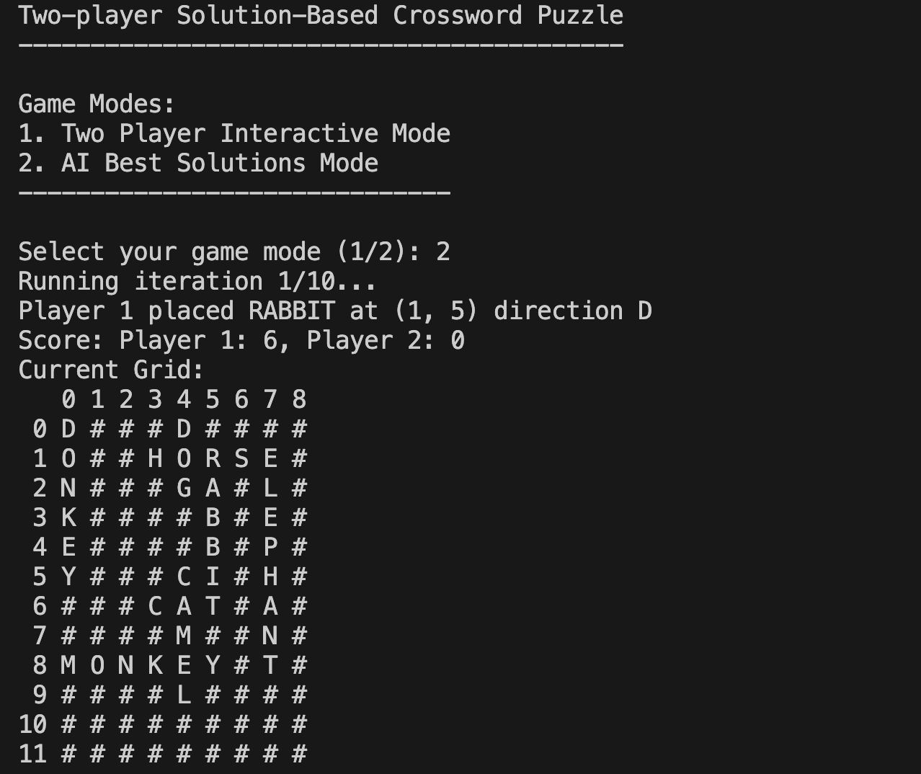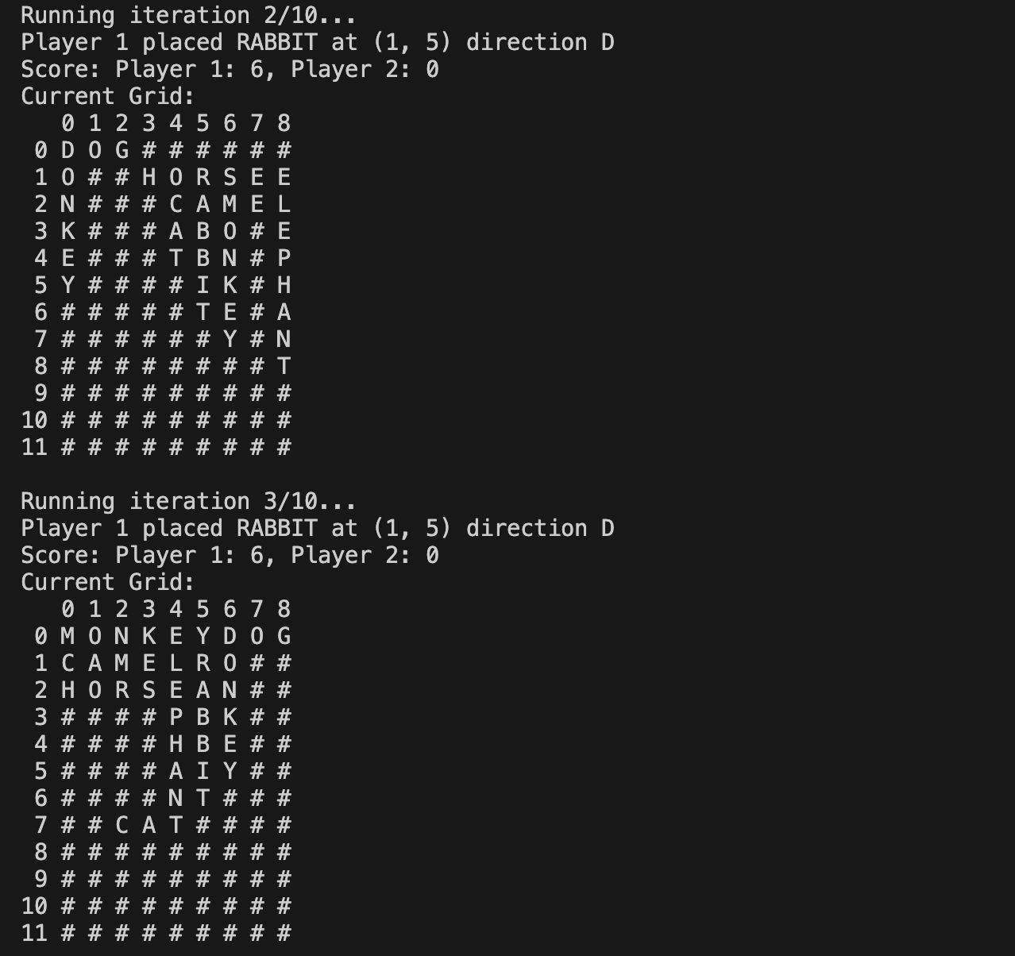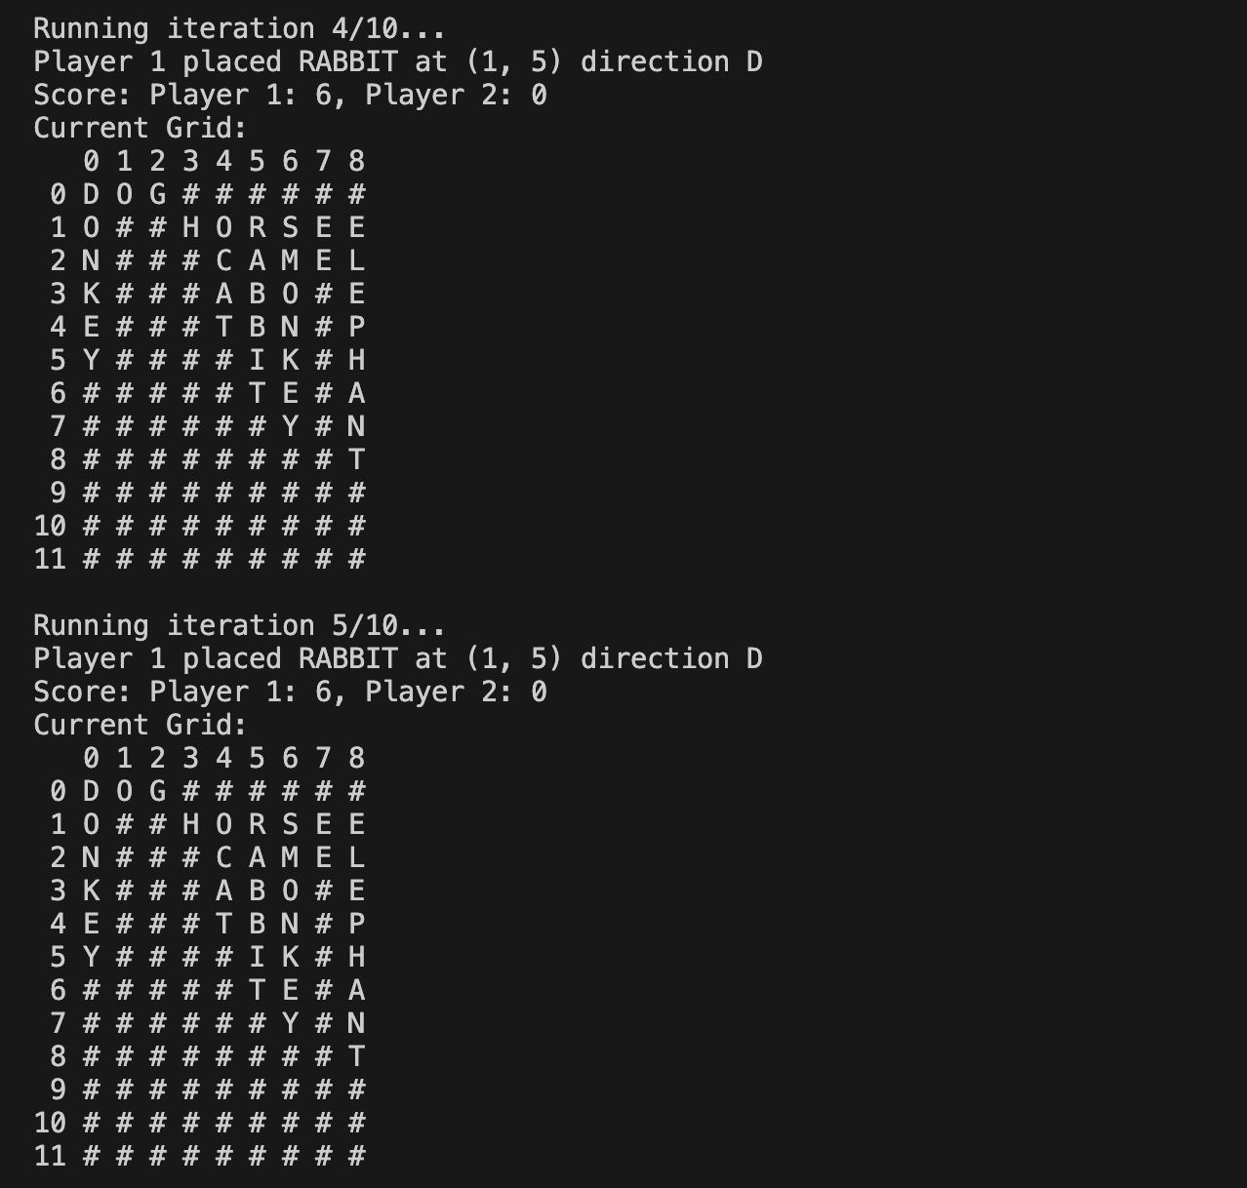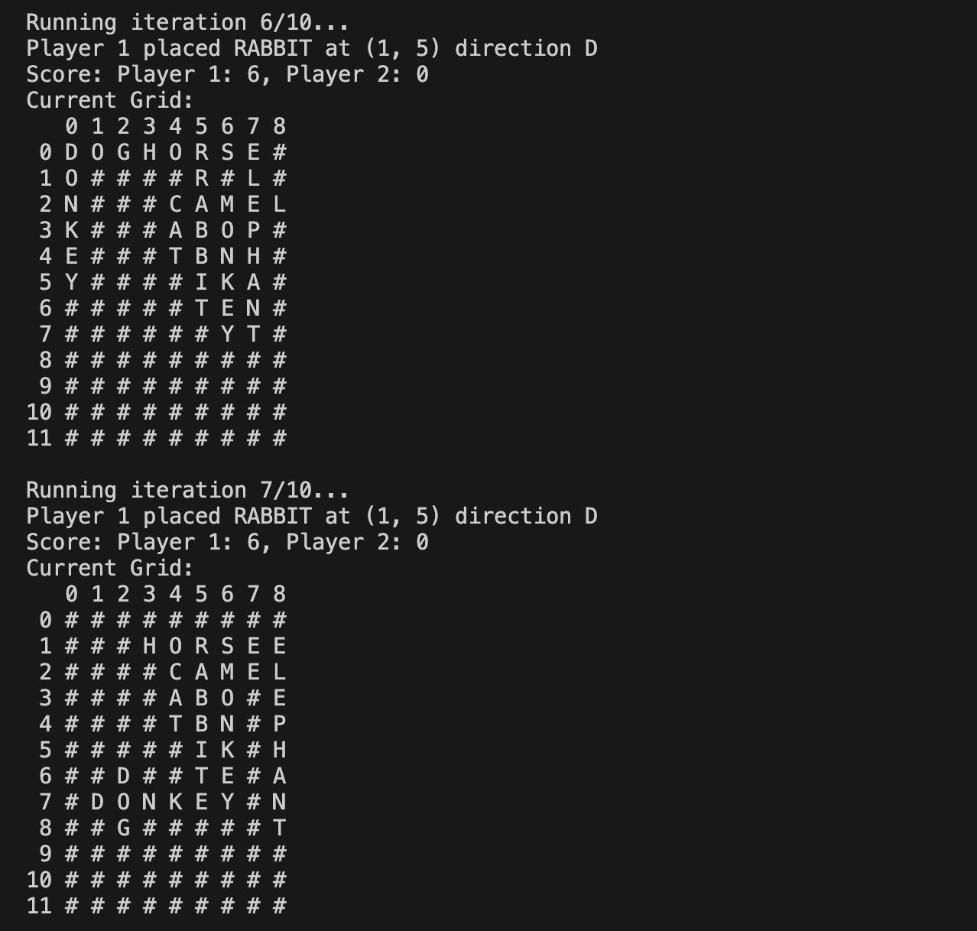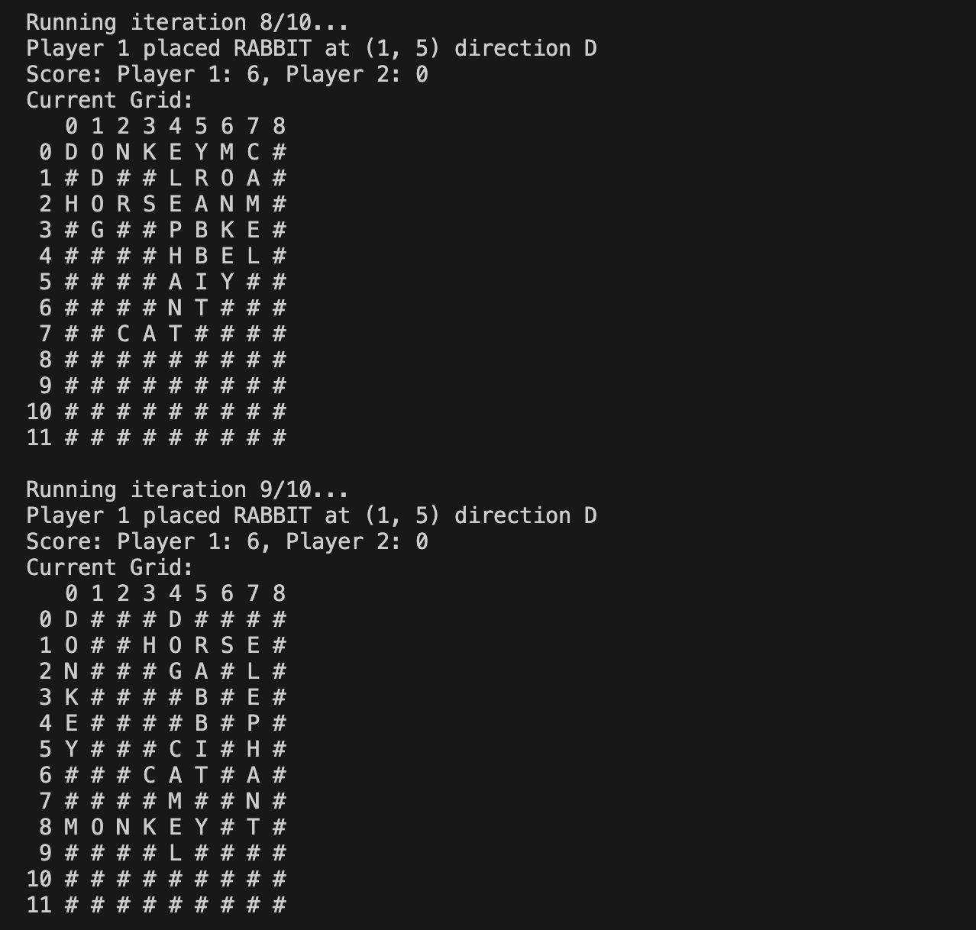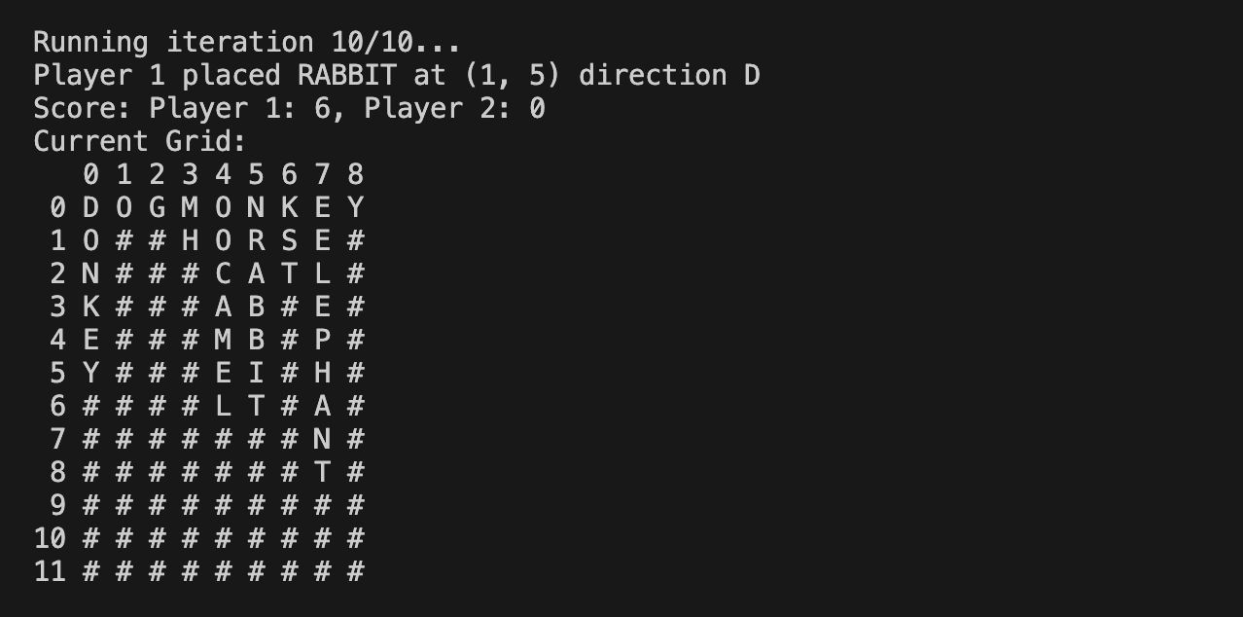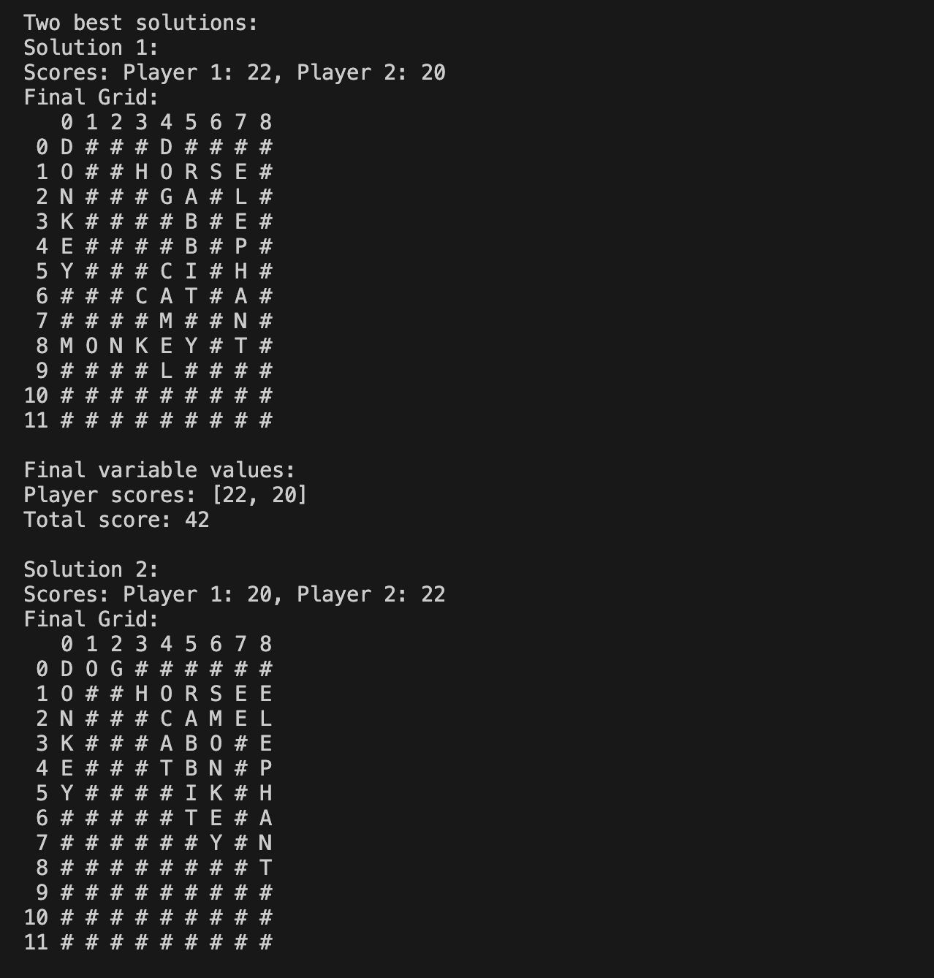

Input Mode 1(Interactive Mode – Output) :

Two-player Solution-Based Crossword Puzzle
------------------------------------------

Game Modes:
1. Two Player Interactive Mode
2. AI Best Solutions Mode
------------------------------
Game started with RABBIT placed at (1,5) direction D
0 1 2 3 4 5 6 7 8
0 # # # # # # # # #
1 # # # # # R # # #
2 # # # # # A # # #
3 # # # # # B # # #
4 # # # # # B # # #
5 # # # # # I # # #
6 # # # # # T # # #
7 # # # # # # # # #
8 # # # # # # # # #
9 # # # # # # # # #
10 # # # # # # # # #
11 # # # # # # # # #

Player 2's turn
Available words: ['CAT', 'DOG', 'ELEPHANT', 'MONKEY', 'HORSE', 'CAMEL', 'DONKEY']
Player 2 placed CAT at (6, 3) direction A
Score: Player 1: 6, Player 2: 3
0 1 2 3 4 5 6 7 8
0 # # # # # # # # #
1 # # # # # R # # #
2 # # # # # A # # #
3 # # # # # B # # #
4 # # # # # B # # #
5 # # # # # I # # #
6 # # # C A T # # #
7 # # # # # # # # #
8 # # # # # # # # #
9 # # # # # # # # #
10 # # # # # # # # #
11 # # # # # # # # #

Player 1's turn
Available words: ['DOG', 'ELEPHANT', 'MONKEY', 'HORSE', 'CAMEL', 'DONKEY']
Player 1 placed CAMEL at (6, 3) direction D
Score: Player 1: 11, Player 2: 3
0 1 2 3 4 5 6 7 8
0 # # # # # # # # #
1 # # # # # R # # #
2 # # # # # A # # #
3 # # # # # B # # #
4 # # # # # B # # #
5 # # # # # I # # #
6 # # # C A T # # #
7 # # # A # # # # #
8 # # # M # # # # #
9 # # # E # # # # #
10 # # # L # # # # #
11 # # # # # # # # #

Player 2's turn
Available words: ['DOG', 'ELEPHANT', 'MONKEY', 'HORSE', 'DONKEY']
Player 2 placed MONKEY at (8, 3) direction A
Score: Player 1: 11, Player 2: 9
0 1 2 3 4 5 6 7 8
0 # # # # # # # # #
1 # # # # # R # # #
2 # # # # # A # # #
3 # # # # # B # # #
4 # # # # # B # # #
5 # # # # # I # # #
6 # # # C A T # # #
7 # # # A # # # # #
8 # # # M O N K E Y
9 # # # E # # # # #
10 # # # L # # # # #
11 # # # # # # # # #

Player 1's turn
Available words: ['DOG', 'ELEPHANT', 'HORSE', 'DONKEY']
Player 1 placed HORSE at (4, 7) direction D
Score: Player 1: 16, Player 2: 9
0 1 2 3 4 5 6 7 8
0 # # # # # # # # #
1 # # # # # R # # #
2 # # # # # A # # #
3 # # # # # B # # #
4 # # # # # B # H #
5 # # # # # I # O #
6 # # # C A T # R #
7 # # # A # # # S #
8 # # # M O N K E Y
9 # # # E # # # # #
10 # # # L # # # # #
11 # # # # # # # # #

Player 2's turn
Available words: ['DOG', 'ELEPHANT', 'DONKEY']
Player 2 placed DOG at (5, 6) direction D
Score: Player 1: 16, Player 2: 12
0 1 2 3 4 5 6 7 8
0 # # # # # # # # #
1 # # # # # R # # #
2 # # # # # A # # #
3 # # # # # B # # #
4 # # # # # B # H #
5 # # # # # I D O #
6 # # # C A T O R #
7 # # # A # # G S #
8 # # # M O N K E Y
9 # # # E # # # # #
10 # # # L # # # # #
11 # # # # # # # # #

Player 1's turn
Available words: ['ELEPHANT', 'DONKEY']
Player 1 placed ELEPHANT at (2, 0) direction A
Score: Player 1: 24, Player 2: 12
0 1 2 3 4 5 6 7 8
0 # # # # # # # # #
1 # # # # # R # # #
2 E L E P H A N T #
3 # # # # # B # # #
4 # # # # # B # H #
5 # # # # # I D O #
6 # # # C A T O R #
7 # # # A # # G S #
8 # # # M O N K E Y
9 # # # E # # # # #
10 # # # L # # # # #
11 # # # # # # # # #

Player 2's turn
Available words: ['DONKEY']
Player 2 placed DONKEY at (3, 8) direction D
Score: Player 1: 24, Player 2: 18
0 1 2 3 4 5 6 7 8
0 # # # # # # # # #
1 # # # # # R # # #
2 E L E P H A N T #
3 # # # # # B # # D
4 # # # # # B # H O
5 # # # # # I D O N
6 # # # C A T O R K
7 # # # A # # G S E
8 # # # M O N K E Y
9 # # # E # # # # #
10 # # # L # # # # #
11 # # # # # # # # #

Game Over!
Final Scores: Player 1: 24, Player 2: 18
Player 1 wins!

Problem statement 2 : Logic - Water Resource Location

- Objective:
- To develop a rule-based system in Prolog that can predict the most suitable water resource for a given location based on specific attributes.
- Derive the rules from the given decision tree and code as Prolog rules.
- Interactive implementation. Dynamic inputs-based run of the logic expert system with step wise options display and error free recommendation & ending

- Our Understanding of the Problem:
- Decision-Based Water Resource Selection:
- The Decision Tree helps determine the most suitable water resource (Rainwater, River Water, Lake, or Groundwater) based on location attributes.
- Each location has specific features that impact the selection.
- Decision-Making Process:
- The Decision Tree follows a hierarchical structure, where each node represents a decision point based on feature values.
- A location's features determine the path in the tree, leading to a final classification (water resource recommendation).
- Prolog-Based Implementation:
- The decision process will be translated into Prolog rules.
- The program will prompt the user for relevant location attributes.
- Based on inputs, Prolog will evaluate rules and predict the best water source.

- Problem Output Screenshots:
